|  |  |  |  |
| --- | --- | --- | --- |
| Boulder Cr | NDS3 | 40.049791 | -105.145899 |

Between 75th and 95th St @ Duncan Lane <http://waterdata.usgs.gov/co/nwis/uv?cb_00065=on&cb_00060=on&format=gif_stats&period=&begin_date=2012-08-17&end_date=2012-09-07&site_no=06730200> 20120910 15:31

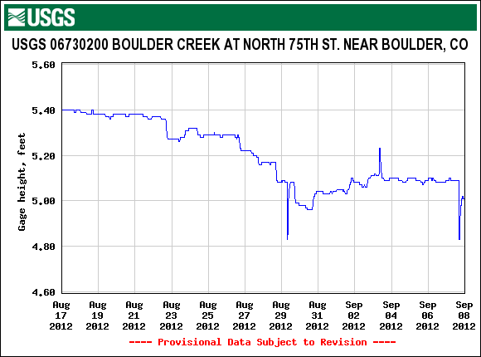

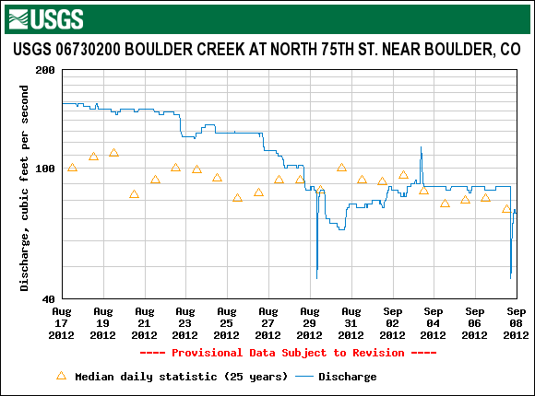

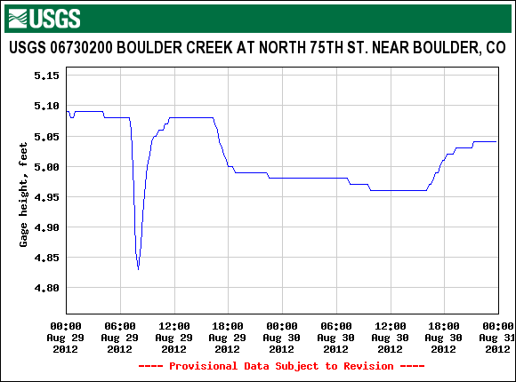

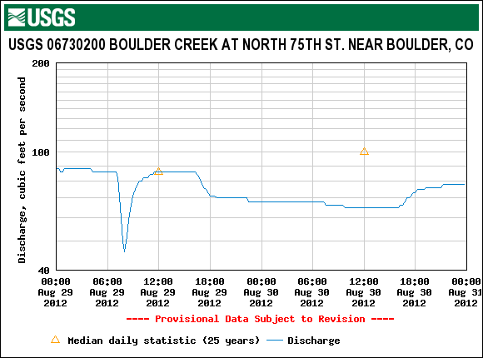



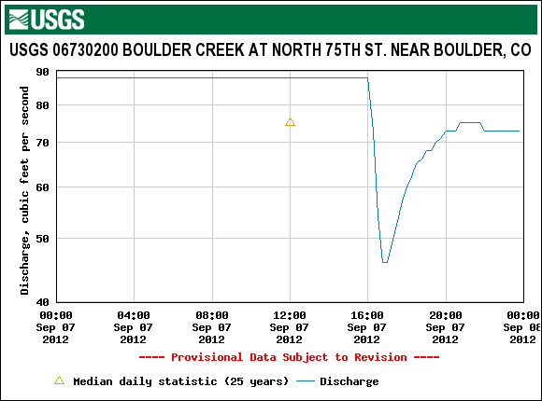



























Figure . <http://acwi.gov/monitoring/conference/2012/ESA3_Rounds.pdf>









